**Human Centric Design Techniques used for the development.**

1. **Customer Interviews:** We formed a group of likely end users. Based on our initial understanding, we created a set of Hypothesis which we tried to prove true or false with these customer interviews. Some of the hypotheses were proven false and we had to pivot and iteratively refine them. Below is the first version of the Use case and User Interface design.

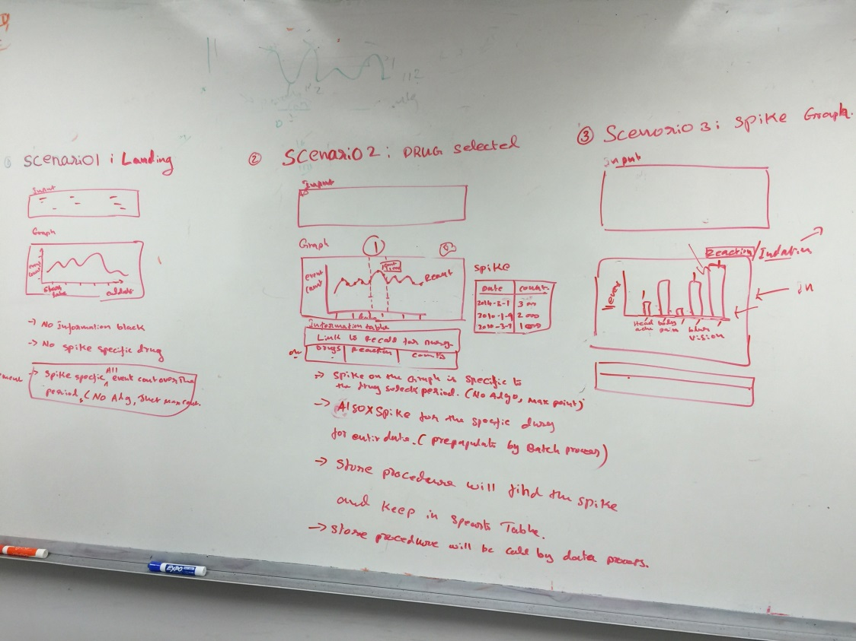

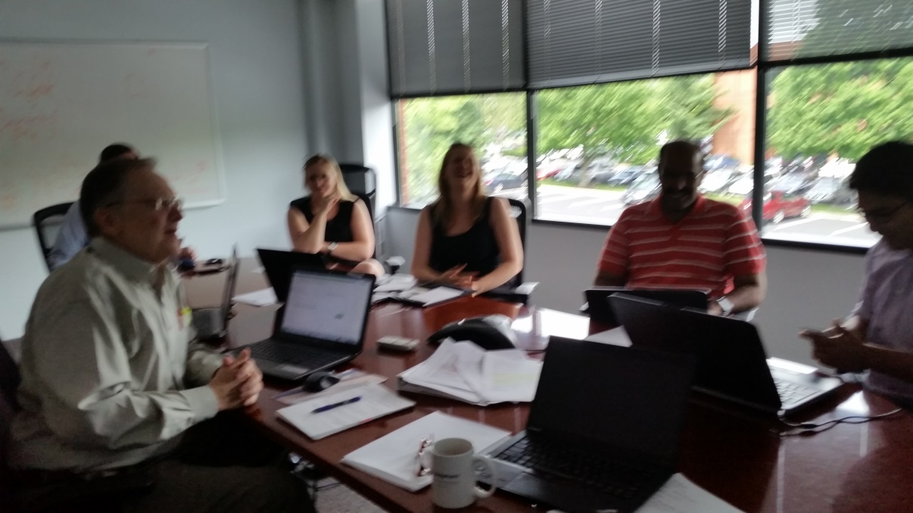

2. **Wireframe:** To get deeper feedback for the UI, we created the first wireframe. The wireframe was again reviewed with the team and the feedback was incorporated.

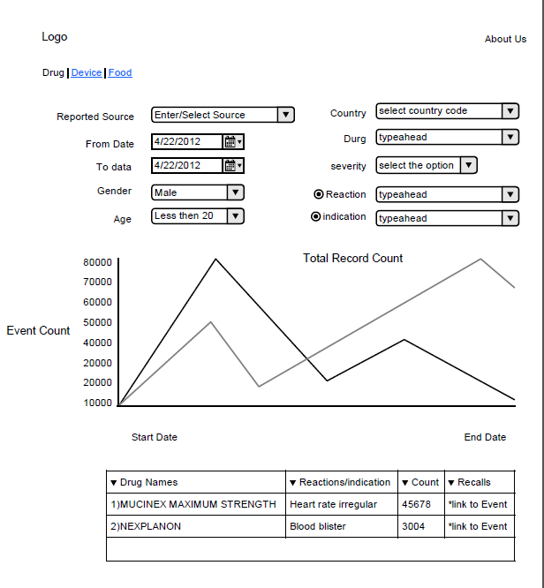

3. **HTML prototype** as the next step. We took the feedback from the wireframe and created the first version of the User Interface. This was an HTML prototype to get an early feedback.

